- create database Organization;
-- use database for adding table
- use Organization;
-- creation of first table
- create table Employee(
EmpID int Primary key,
EmpName varchar(25),
DeptID int,
DeptName varchar(25),
Salary decimal(10, 2) not null,
Joiningdate date not null
);

-- second table
- create table Department(
DeptID int,
DeptName varchar(25),
location varchar(20)
);

Inserting data into table :
insert into Employee values(101,'Komal',1,'HR',25000,'2026-06-23');
insert into Employee values(101,'Komal',1,'HR',25000,'2026-06-23');
insert into Employee values(102,'Smita',2,'QA',35000,'2025-02-20');
insert into Employee values(103,'Sagar',1,'HR',25000,'2024-05-12');
insert into Employee values(104,'Namrata',3,'Marketing',25000,'2026-06-23');
insert into Employee values(105,'Pankaj',4,'Sales',23000,'2022-06-06');
insert into Employee values(105,'Pankaj',4,'Sales',23000,'2022-06-06');
insert into Employee values(106,'Vijay',1,'HR',20000,'2021-04-02');
insert into Employee values(107,'Divisha',2,'QA',55000,'2020-09-11');
insert into Employee values(108,'Komal',1,'HR',25000,'2025-02-20');
insert into Employee values(109,'Riyyansh',3,'Marketing',40000,'2026-06-23');
insert into Employee values(110,'Smita',4,'Sales',15000,'2018-08-09');
inserting data into Department table:
insert into Department values(1,'HR','Pune');
insert into Department values(2,'QA','Mumbai');
insert into Department values(1,'HR','Pune');
insert into Department values(3,'Marketing','Pune');
insert into Department values(4,'Sales','Pune');
insert into Department values(1,'HR','Pune');
insert into Department values(2,'QA','Mumbai');
insert into Department values(1,'HR','Pune');
insert into Department values(3,'Marketing','Pune');
insert into Department values(4,'Sales','Pune');

- Top 5 highest salary employees
select EmpName,DeptName,salary from employee
order by salary DESC
limit 5;

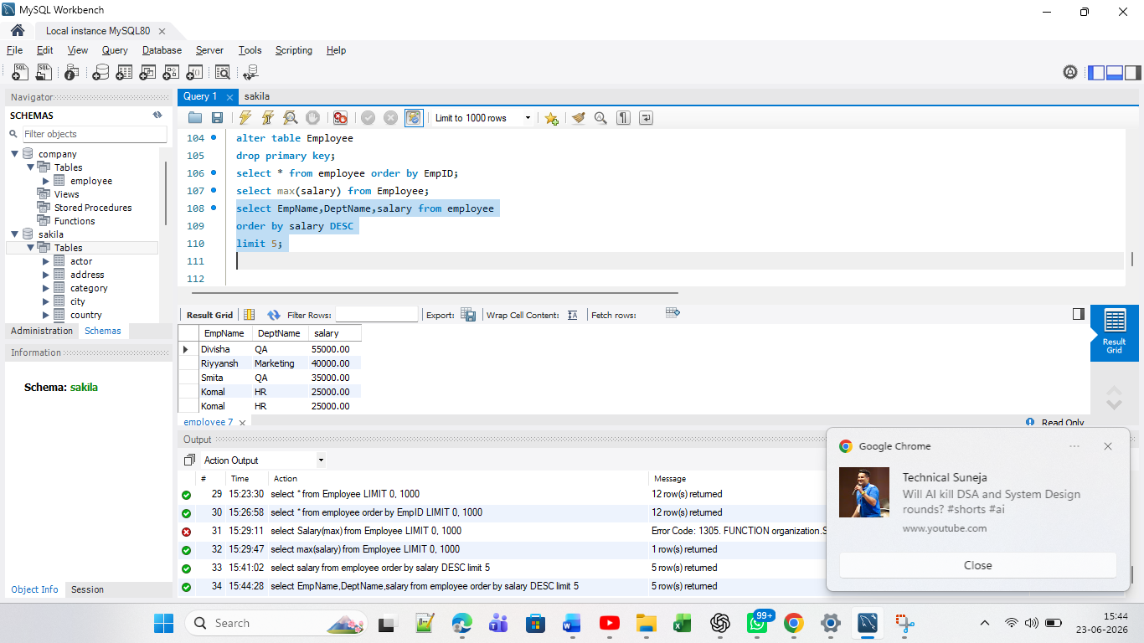
2. Department wise employee count
select count(*) from employee group by DeptID;
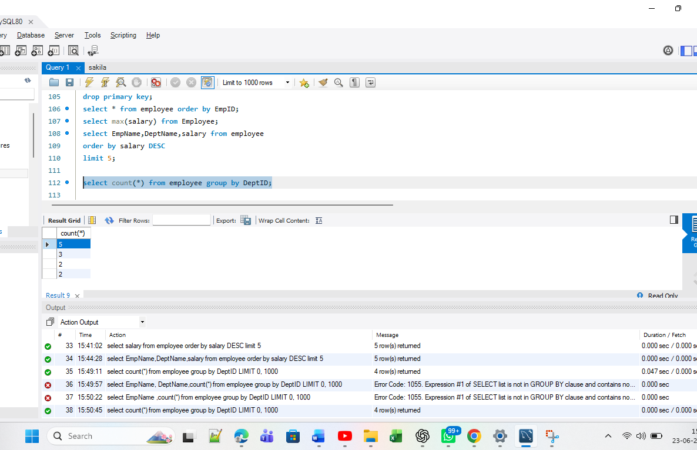

3. Find Second highest salary
select max(salary) from employee where salary<(select max(salary) from employee);
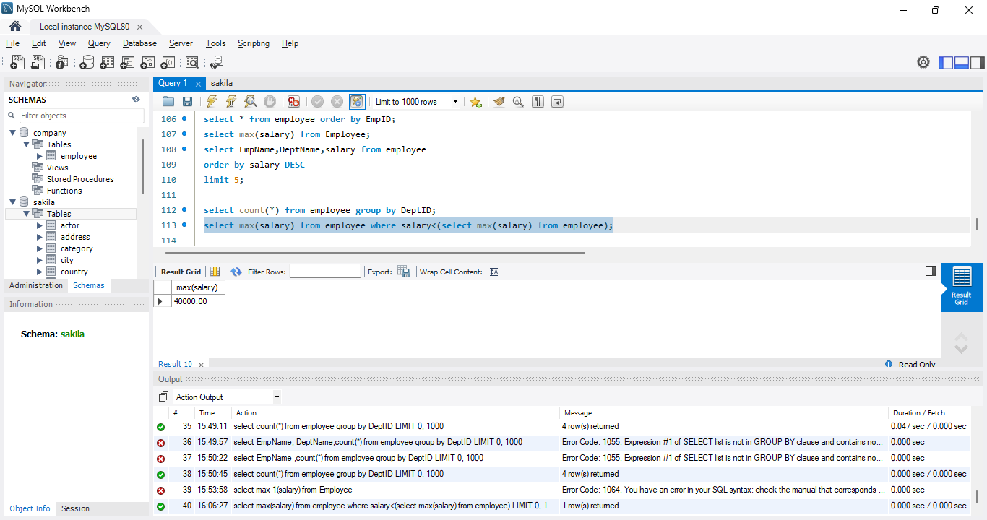
4. Employees whose salary > department average salary
select EmpName, salary, deptID
FROM Employee e
WHERE salary > (
SELECT AVG(salary)
FROM Employee
WHERE deptID = e.deptID
);
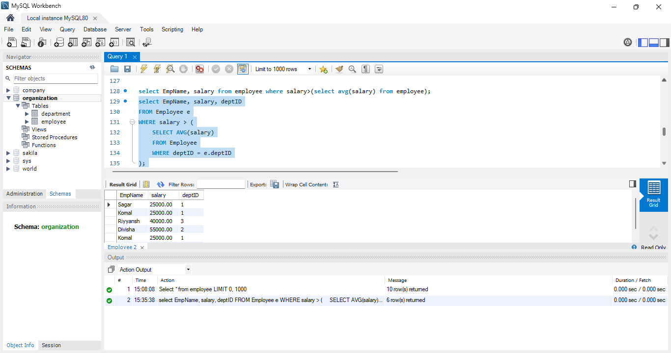

5. Inner Join
SELECT e.empid,
e.empname,e.deptid, d.deptname
FROM Employee e
INNER JOIN Department d
ON e.deptid = d.deptid;
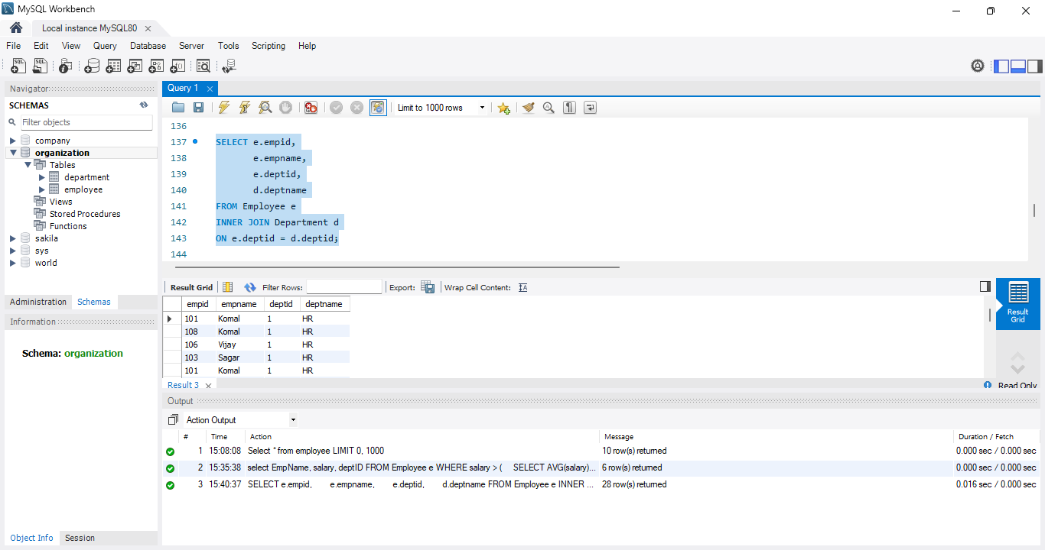

6.left join:
SELECT e.empid,
e.empname,
e.deptid,
d.deptname
FROM Employee e
INNER JOIN Department d
ON e.deptid = d.deptid;
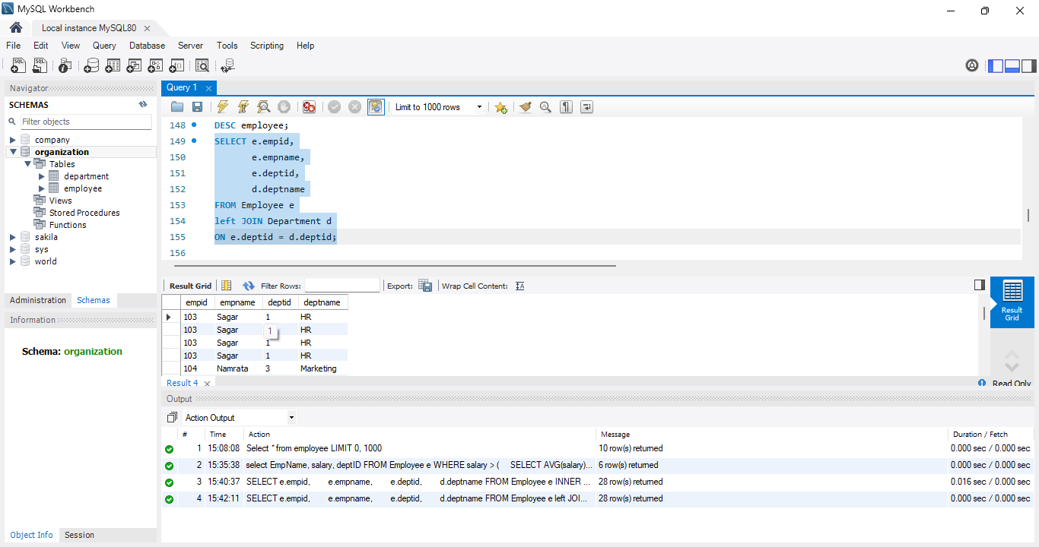

7.group by using having
select deptid, avg(salary) from employee group by deptid having avg(salary)>30000;
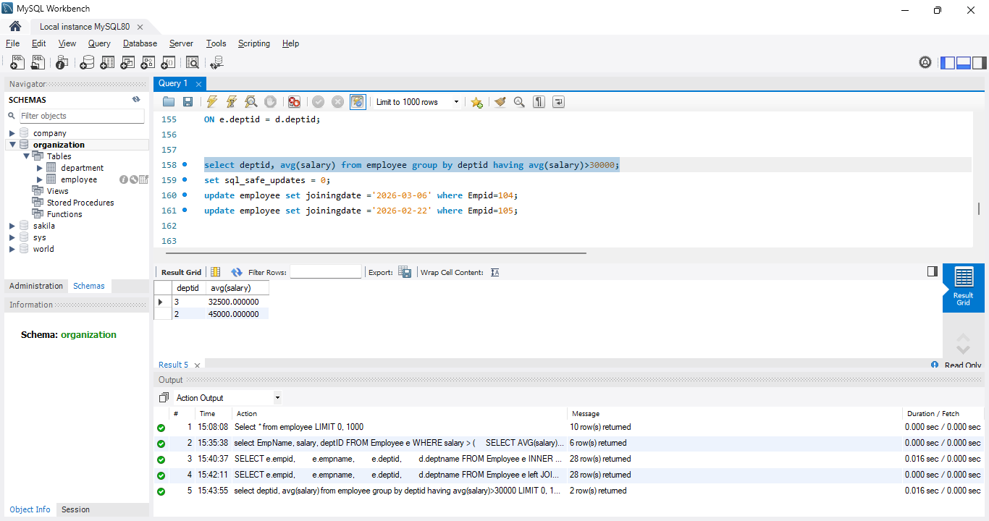
8. Employees hired in last 6 months
SELECT *FROM Employee
WHERE joiningdate >= DATE_SUB(CURDATE(), INTERVAL 6 MONTH);
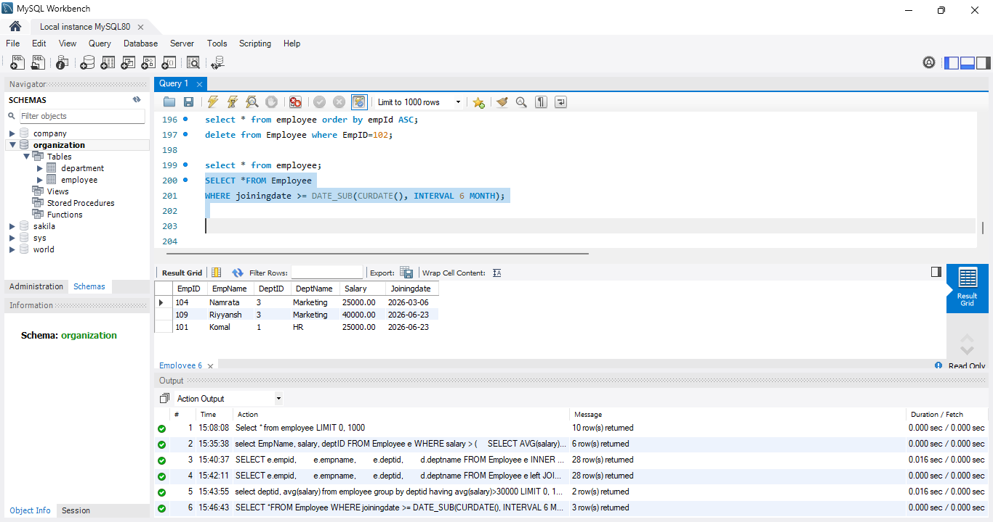

9. Find the Duplicates records
Emp table
select empid ,count(*) from employee group by Empid having count(*)>1;
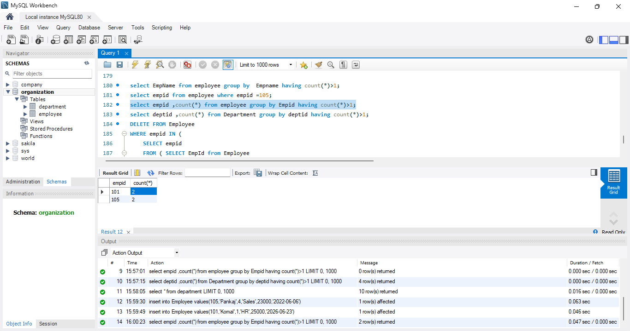
dept table
select deptid ,count(*) from Department group by deptid having count(*)>1;
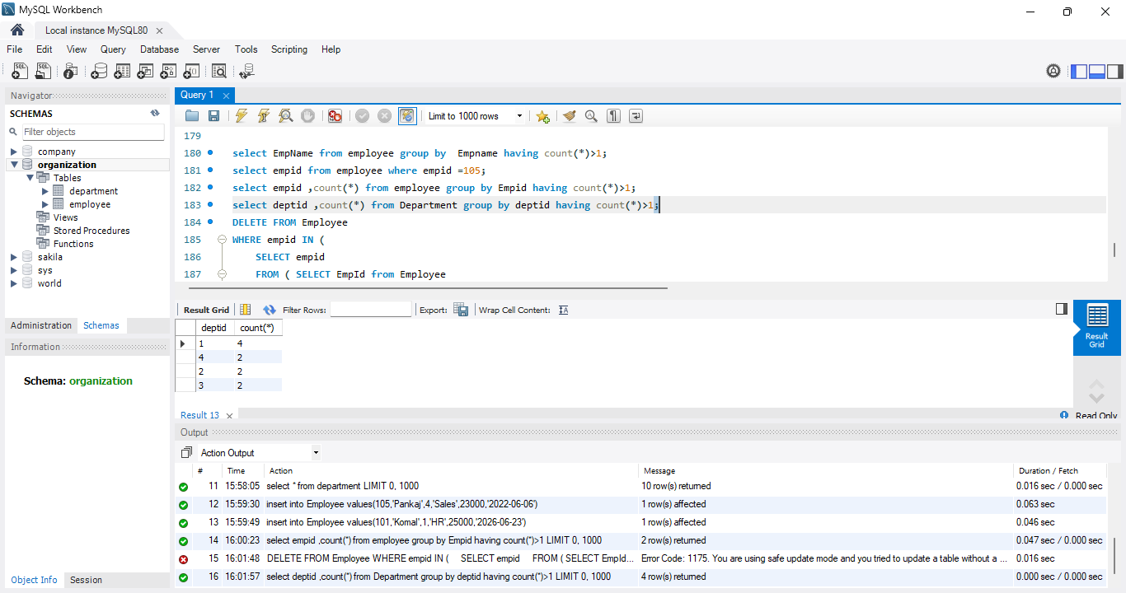

10. How to remove the duplicates record Submission
SET SQL_SAFE_UPDATES = 0;
DELETE e1
FROM Employee e1
JOIN Employee e2
ON e1.EmpID = e2.EmpID
AND e1.ID > e2.ID;

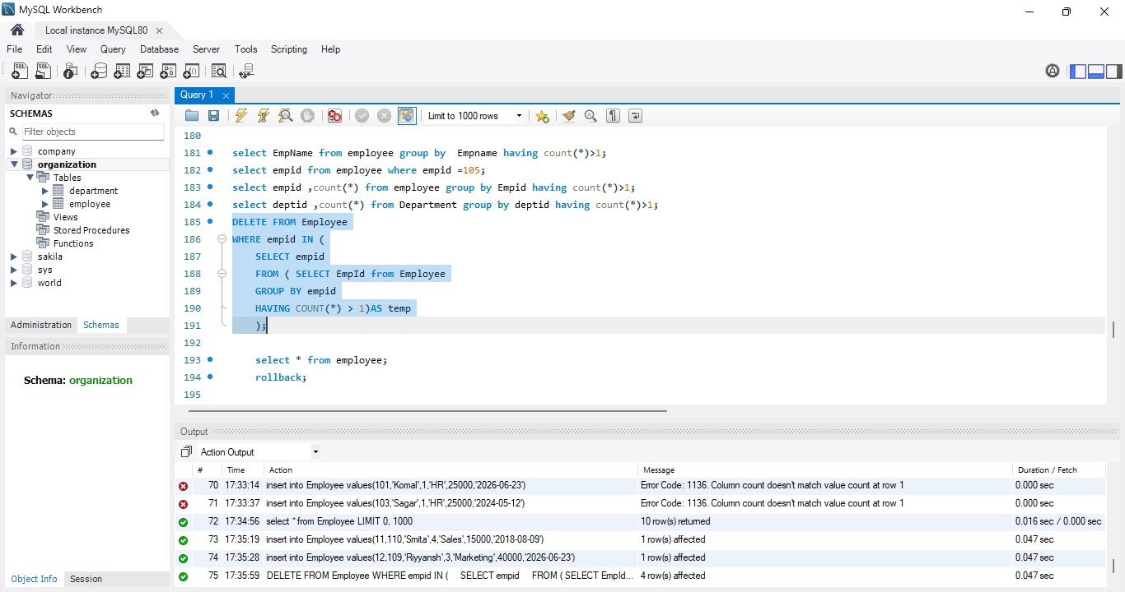

Department table:
DELETE d1
FROM Department d1
JOIN Department d2
ON d1.DeptID = d2.DeptID
AND d1.ID > d2.ID;
